1(d)

|  |  |
| --- | --- |
| k Value | Validation Accuracy |
| 1 | 0.206 |
| 4 | 0.2 |
| 8 | 0.2 |
| 16 | 0.194 |

From the table, it is evident that k=1 offers the highest accuracy on the validation set, making it the most suitable hyperparameter for this dataset.

1(e)

With the optimal hyperparameter k=1, the k-NN classifier was then applied to the dimensionally reduced test dataset. The performance was evaluated based on prediction accuracy:

Test Accuracy: The model achieved an accuracy of 0.19 on the test dataset.

1(f)

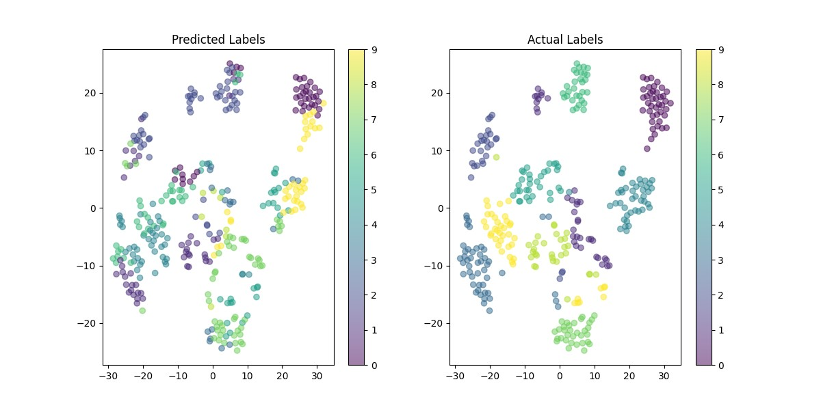

2(g)

